Hands-on 8 - Update a country based on code

Name: Shubham Sangram Bej

Aim
To update an existing country using Spring Data JPA.

Theory
The save() method updates an existing record when the primary key already exists. Hibernate automatically detects that the entity is already present and executes an update operation.

Procedure
- Retrieve the country using its code.
- Modify the country name.
- Invoke save().
- Verify changes.

Screenshots

CountryService.java
package com.cognizant.ormlearn.service;
import com.cognizant.ormlearn.model.Country;
import com.cognizant.ormlearn.repository.CountryRepository;
import org.springframework.beans.factory.annotation.Autowired;
import org.springframework.stereotype.Service;
import org.springframework.transaction.annotation.Transactional;
import java.util.Optional;
import com.cognizant.ormlearn.service.exception.CountryNotFoundException;
import java.util.List;
@Service
public class CountryService {
@Autowired
private CountryRepository countryRepository;
@Transactional
public List<Country> getAllCountries() {
return countryRepository.findAll();
}
@Transactional
public Country findCountryByCode(String countryCode) throws CountryNotFoundException {
Optional<Country> result = countryRepository.findById(countryCode);
if (!result.isPresent()) {
throw new CountryNotFoundException("Country not found with code: " + countryCode);
}
Country country = result.get();
return country;
}
@Transactional
public void addCountry(Country country) {
countryRepository.save(country);
}
@Transactional
public void updateCountry(String code, String name)
throws CountryNotFoundException {
Country country = findCountryByCode(code);
country.setName(name);
countryRepository.save(country);
}
}

OrmLearnApplication.java
package com.cognizant.ormlearn;
import com.cognizant.ormlearn.model.Country;
import com.cognizant.ormlearn.service.CountryService;
import org.slf4j.Logger;
import org.slf4j.LoggerFactory;
import org.springframework.boot.SpringApplication;
import org.springframework.boot.autoconfigure.SpringBootApplication;
import org.springframework.context.ApplicationContext;
import java.util.List;
@SpringBootApplication
public class OrmLearnApplication {
private static final Logger LOGGER =
LoggerFactory.getLogger(OrmLearnApplication.class);
private static CountryService countryService;
public static void main(String[] args) {
ApplicationContext context = SpringApplication.run(OrmLearnApplication.class, args);
LOGGER.info("Inside main");
countryService = context.getBean(CountryService.class);
testGetAllCountries();
testFindCountryByCode();
testAddCountry();
testUpdateCountry();
}
private static void testGetAllCountries() {
LOGGER.info("Start");
List<Country> countries = countryService.getAllCountries();
LOGGER.debug("countries={}", countries);
LOGGER.info("End");
}
private static void testFindCountryByCode() {
LOGGER.info("Start");
try {
Country country = countryService.findCountryByCode("PT");
LOGGER.debug("Country={}", country);
} catch (Exception e) {
LOGGER.error(e.getMessage());
}
LOGGER.info("End");
}
private static void testAddCountry() {
LOGGER.info("Start");
Country country = new Country();
country.setCode("ZZ");
country.setName("Shubham's Land");
countryService.addCountry(country);
try {
Country addedCountry = countryService.findCountryByCode("ZZ");
LOGGER.debug("Added Country={}", addedCountry);
} catch (Exception e) {
LOGGER.error(e.getMessage());
}
LOGGER.info("End");
}
private static void testUpdateCountry() {
LOGGER.info("Start");
try {
countryService.updateCountry("ZZ", "OpenAI Country");
Country country = countryService.findCountryByCode("ZZ");
LOGGER.debug("Updated Country={}", country);
} catch (Exception e) {
LOGGER.error(e.getMessage());
}
LOGGER.info("End");
}
}

Console Output

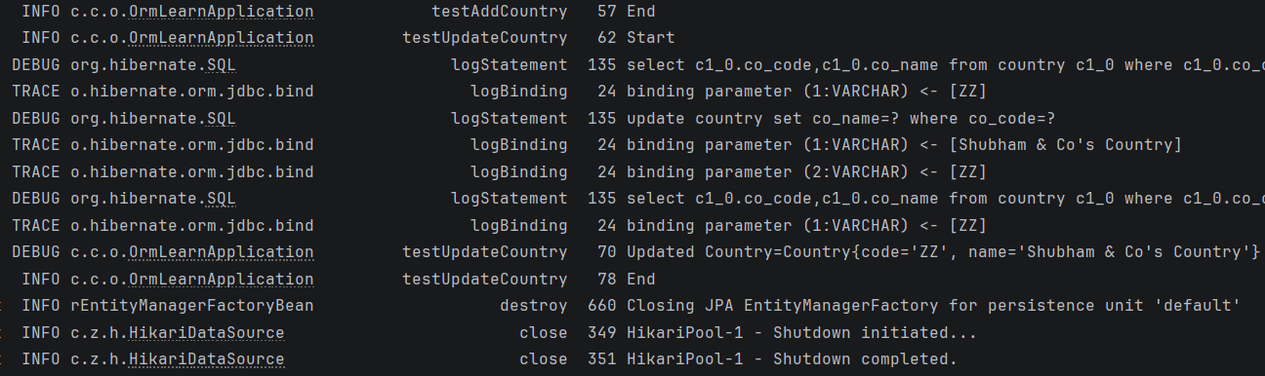

MySQL Workbench Output

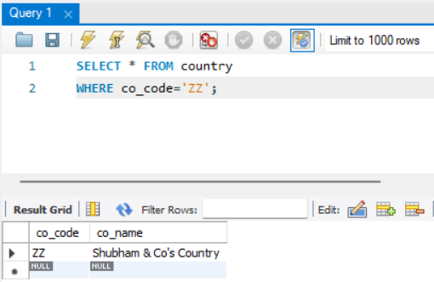

Result
The selected country was updated successfully.

Conclusion
Spring Data JPA simplifies update operations by using the same save() method for both insertion and modification.

